[](http://crossmark.crossref.org/dialog/?doi=10.1145%2F3196709.3196810&domain=pdf&date_stamp=2018-06-08)

**Designing for an other Home: Expanding and Speculating on Different Forms of Domestic Life**

**Doenja Oogjes**

School of Interactive Arts and Technology, Simon Fraser University, Surrey, British Columbia, Canada [doogjes@sfu.ca](mailto:doogjes@sfu.ca)

**William Odom**

School of Interactive Arts and Technology, Simon Fraser University, Surrey, British Columbia, Canada [wodom@sfu.ca](mailto:wodom@sfu.ca)

**Pete Fung**

Faculty of Design, Emily Carr University of Art and Design, Vancouver, British Columbia, Canada [peter.hoching@gmail.com](mailto:peter.hoching@gmail.com)

**Abstract**

We report on the design and deployment of a probe study aimed at understanding the values, practices, and perspectives of people that actively embrace living situations that could be considered ‘alternative’ to normative domestic dwellings. In response to the returned probes, the pictorial describes and unpacks speculative interpretations and design responses that (i) propose alternative ways technology could be designed for the home, (ii) embody different ideas of where home is located, (iii) explore how home is constructed, re-made, curated, and pur- sued, and (iv) productively question material, technological, and social boundaries between the home and the outside world.

**Authors Keywords**

Home; Domestic Design; Probes; Design Research.

**ACM Classification Keywords**

H.5.m. Information interfaces and presentation (e.g., HCI): Miscellaneous.

Permission to make digital or hard copies of all or part of this work for personal or classroom use is granted without fee provided that copies are not made or distributed for profit or commercial advantage and that copies bear this notice and the full citation on the first page. Copyrights for com- ponents of this work owned by others than the author(s) must be honored. Abstracting with credit is permitted. To copy otherwise, or republish, to post on servers or to redistribute to lists, requires prior specific permission and/or a fee. Request permissions from [Permissions@acm.org.](mailto:Permissions@acm.org)

DIS ‘18, June 9–13, 2018, , Hong Kong

© 2018 Copyright is held by the owner/author(s). Publication rights licensed to ACM.

ACM ISBN 978-1-4503-5198-0/18/06…$15.00

https://doi.org/10.1145/3196709.3196810

**Introduction**

The DIS and HCI communities have long researched ‘the home’ and ‘domestic life’, and applied diverse methods to these investigations [6,13]. This large body of work has produced important contributions that have impacted how technology can be designed to better support the tasks, routines, and experiences of home life. However, conceptualizations of what the home is, where it resides, how it is made and by whom have arguably remained somewhat narrow in the HCI community. Whether implicitly or explicitly, ‘the home’ is often situated as a house and ‘domestic life’ is frequently cast as the social organization of collocated family members (e.g., a married couple with children). A small selection of prior work has helped expand characterizations of domestic life in HCI through exploring such issues

as: the negotiation of home-life in subsistence, off-the-grid, or co-housing communities [e.g., 11,15,26] as well as practices of making home when living in transitional situations without a central dwelling [e.g., 8,17,19,23,25]. This nascent research offers an important step toward expanding the HCI community’s vision of ‘the home’ and developing a more diverse perspective on what constitutes domestic life. Yet, works like this remain sparse. In our view, more research is needed to further sensitize and expand approaches to designing for alternative sites of domesticity and forms of home life. On a broader level, we see our work as being in line with emerging discussions in the HCI and design communities that articulate the need to advance beyond homogenous visions of domestic technology and embrace a more diverse set of values, perspectives, and agendas in future design initiatives [1,5,10,11,12,14,16,21,24].

Our project is situated in the Greater Vancouver, Canada Metropolitan area. Like many cities worldwide, Vancouver is facing numerous challenges in the areas of affordable housing and availability of space to accommodate growing population density [2,4,22]. These issues as well as a range of social motivations has catalyzed a growing number of citizens in the Vancouver area to adopt living situations that are smaller, mobile, temporary, self-made, and/or collective. Our goal is to better understand the values, practices, and perspectives of people that actively embrace living situations that could be considered ‘alternative’ to normative domestic dwellings; and, to critically inquire into how such insights could inspire new ways of thinking about designing for ‘the home’ and what such a design practice might look like and entail.

Our design research inquiry was grounded in several key related questions (noted in the image below) and divided into two main stages: (i) cultural probes [9] and (ii) developing subsequent speculative responses and interpretations. We began our process by recruiting participants that adopted and, in several cases advocated for, alternative living situations. We recruited

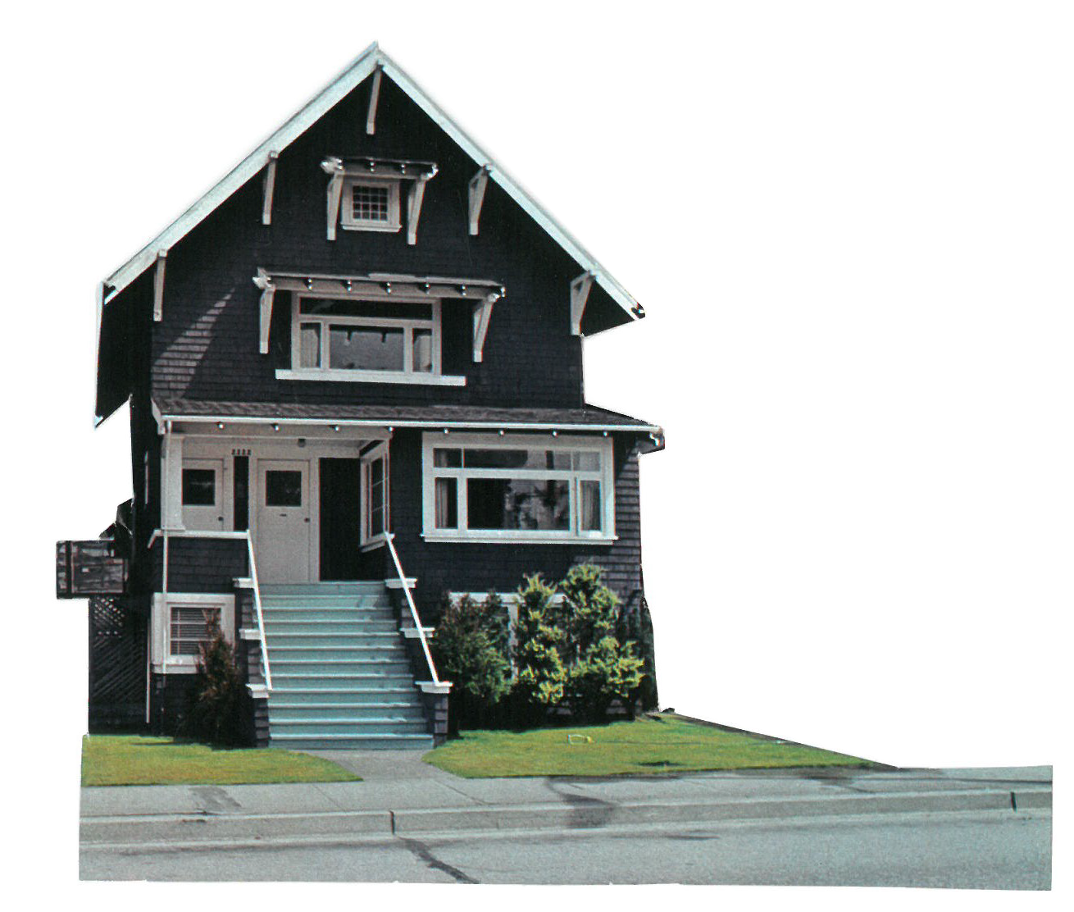

participants by posting flyers at various local organizations (e.g., grocery stores, coffee shops, community centers, libraries, etc.), advertising online in forums, and by word of mouth.

We received notable interest and recruited a diverse set of participants that permanently lived in settings such as a van, boat, micro loft, tiny house, urban condo, collective house, and across many dwellings (as a house/pet sitter).

To better understand the lives, values, and practices our participants, we initially considered conducting an approach that combined in-person interviews with photographic inventories of the things and places that characterized their respective dwelling. However, this approach soon raised tensions. Some of our participants lived in circumstances that were in a legal grey area (e.g., in a van parked on a city street) and/or hard to access (e.g., in a tiny house on a nearby island). It was clear that they all exhibited resourceful, creative, and critical

perspectives on everyday objects and dwellings. These factors made us feel they were ideal candidates for a cultural probes approach [9]. Cultural probes would enable participants to reveal to us their lives and ways of enacting domesticity on their own terms and time. Importantly, we were less concerned with collecting ‘data’ that would be generalizable or representative of an entire population; we wanted to use the returned probe materials for design inspiration to take a step toward speculatively engaging with diverse perspectives of domestic life, considerations of the home, and the role and place of technology within them.

Through our recruitment process, we found that several participants adopted ‘zero-waste’ lifestyles—a philosophy that emphasizes the reuse of materials and products to avoid their disposal. It also emerged that other participants were self-described minimalists and deeply considered their relationship to the things they possessed. These key commitments, along with the questions guiding our inquiry, highly influenced design process and decision making in creating the cultural probe kits. Collectively, the returned probe kits yielded a large amount of inspirational material that included images, audio recordings, written entries, numerous artifacts, and so on. In the second stage of our project, we chose to generatively engage with the returned probe materials by developing a series of speculative interpretations and design responses. Our aim was to explore and cultivate an attitude toward design for other, less considered forms of domestic life, and to open up a dialog about different ways that the home and domestic technology could be treated and explored in the DIS and HCI communities. The majority of this pictorial is devoted to unpacking and describing these generative interpretations and responses.

This pictorial makes two contributions. First, it offers a reflective account of the designing and making of highly finished cultural probe kits. Second, based on the probe materials returned by our participants, it proposes a series of speculative interpretations and design responses to reflexively open up different possibilities and provocations for future research and practice to design technology for other homes in the HCI and design communities.

The  **Tiny Home Dweller** lives on Gambier Island. Her tiny home set up consists of one 16 x16 house, a separate 8x8 bathroom and a woodshed and cold room for food storage. She has lived there for 13 years. As a sustainability educator, she is knowledgeable of rules, regulations and impact around waste and specifically through living on the island where waste collection is sparse, she has over time grown into living more zero-waste. Her husband comes to the island in the weekends, and during the week works in Vancouver. He lives in a  **Micro Loft**

**OUR PARTICIPANTS**

In recruiting our participants, we reached out to people living in non-normative living situations. We soon realized how these living situations extended to values and lifestyles that at times overlapped. We will describe these on this page.

**Zero-waste** living aims to reduce landfill waste in everyday life, which entails consuming less, using less plastic, shopping packaging-free and being resourceful and thoughtful about materials in everyday life.

Zero-waste to an extent overlaps with minimalism, which some of our participants adopted as well.  **Minimalism** also focuses on consuming less, but rather than being environmentally motivated, minimalism looks to establish more fulfilled lives with less stuff. The Tiny home movement is in part connected to minimalism, as an effect of space limitations and similar anti- consumerist motivations.

Other participants adopted  **Urbanism** in taking maximal advantage of the city’s infrastructure, e.g. bike- and car-shares and public transport. Further, our participants all advocated and promoted their living situations in response to the housing crunch in Vancouver.

**Tiny Apartment**. Both of these places are considered home to the couple with an ongoing exchange between them.

The **Van Dweller** spent last year converting her second van and has been living in a van for 4 years. She organizes monthly Vehicle Dweller Meetups in Vancouver to get together with other van dwellers and to promote the van lifestyle. She works as a shuttle bus driver.

The **Boat Dweller** has been living on her boat with her family of four for several years. Advocating slow and steady living, she sails her boat to unconnected zones on local islands and the open ocean to get a break from city life.

The  **Nomadic Pet/House-sitter** moves with her suitcase from one house to the next to take care of cats whose owners are away. Through word of mouth, family and friends and online platforms she has been living rent-free for more than a year. She continually adapts herself to different neighborhoods, cats and living spaces. She sometimes rearranges the furniture, and erases all her traces when it is time to leave. The Nomadic Pet/House-sitter adopts a zero-waste lifestyle and is highly connected to the cities infrastructure, e.g. through her ever-changing commute.

The **Urban Condo Dwelle**r lives with his five kids and utilizes the city and technology to enable his downtown family lifestyle. He is a keen promoter and self-described urbanist, minimalist and technologist and blogs about his lifestyle.

We recruited five **Collective House Dwellers** who had recently started a collective based on their shared ideas of what they wanted a house to feel like. The collective holds biweekly house meetings to continue these commitments, including maintaining a supportive community, creating a safe and inclusive space and drawing energy from each other’s support.

### OUR MATERIAL APPROACH

On the whole, our participants all reflected a commitment to resourceful ways of living and, albeit to differing degrees, re-use, sustainability, minimalism; on a basic level, our cultural probes kits needed to reflect this. To support this goal and empathize with our participants’ commitments, we explored materials that could be adapted in the design and making of our probes. To support the sustainable and resourceful goals of our participants, we made our own paper recycled from paper scraps produced in our studio. We also used discarded fabrics such as bed sheets, old woolen sweaters and blankets to create our probe exercises. We responded to concerns of mobility and re-use by using durable materials such as metal and in creating a probe-bag that could be easily transported, passed on and be used again for next deployments.

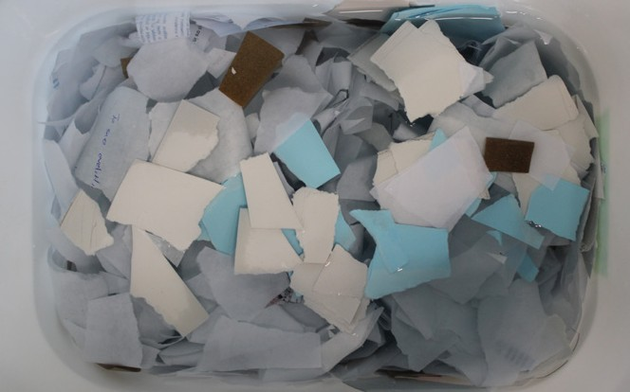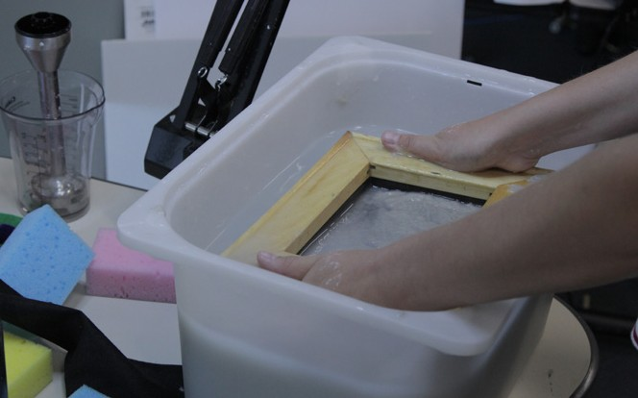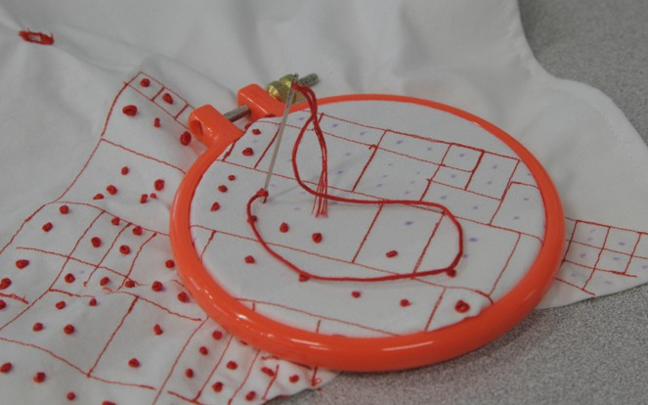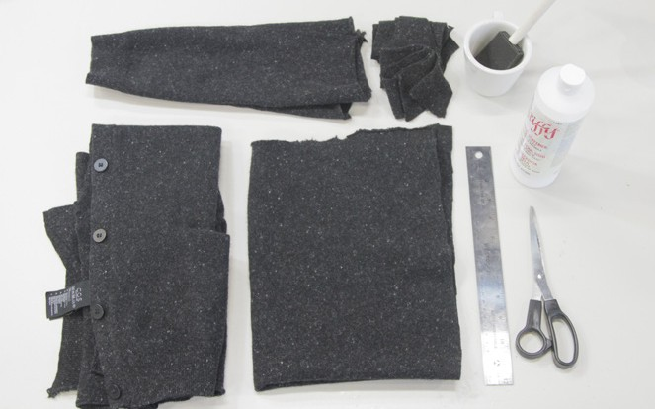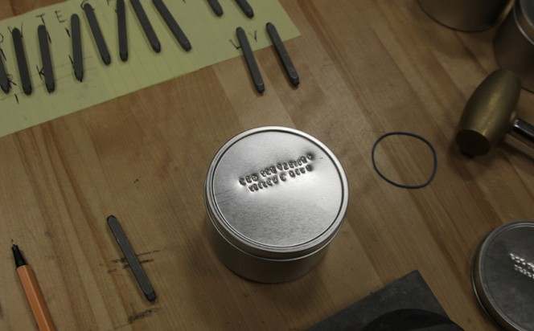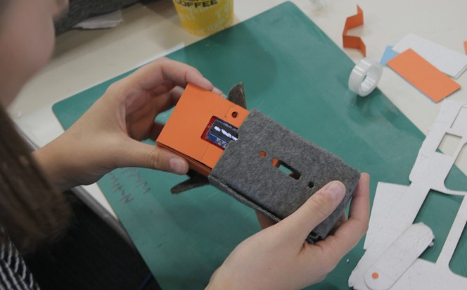

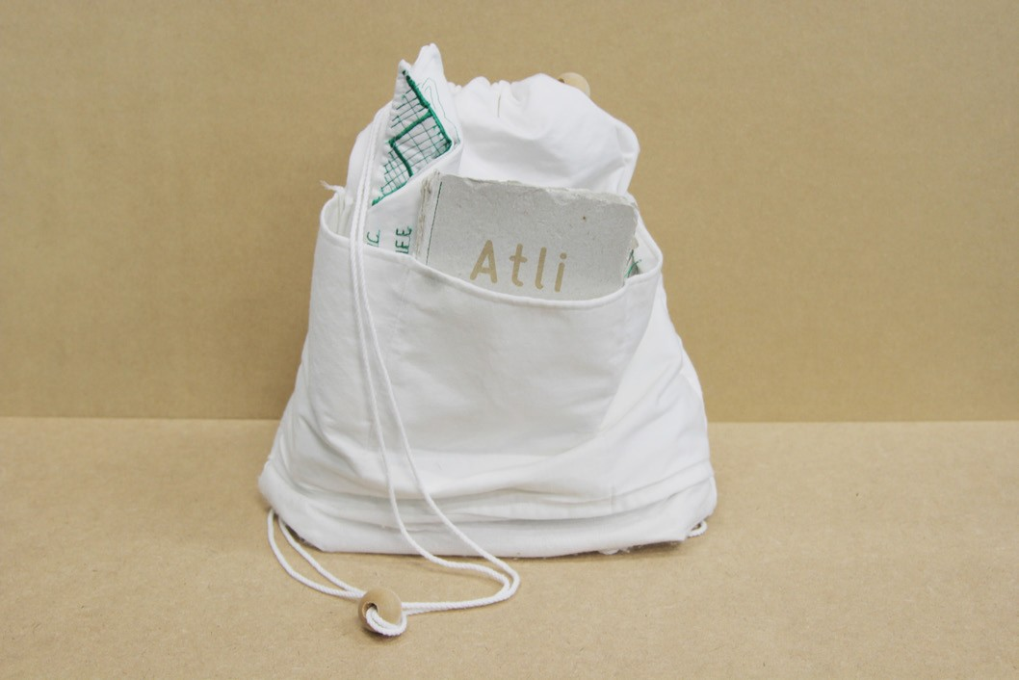

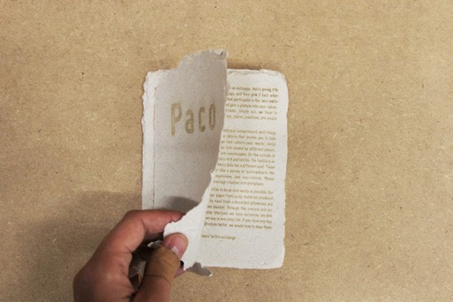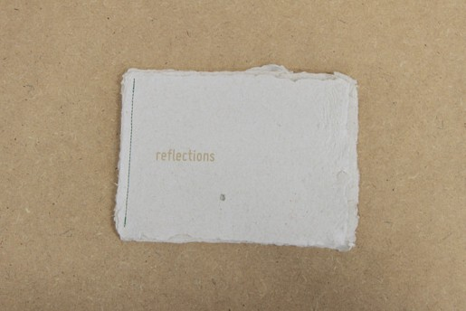

The probe exercises were organized in a canvas drawstring bag with several pockets and compartments, created out of the discarded sheets. Each probe bag was deployed with multiple participants. For each new deployment, the bag was personalized and tailored to the participants’ specific living situation. At the same time, we included prompts and exercises that further emphasized the ongoing nature of the bag.

For each participant, we created a personalized invitation that exhibited her or his name on the front cover and included a brief statement about our design studio, aims of our project, and a brief summary of each probe task. We etched all writing appearing on the invitation with a laser cutter to avoid using inorganic materials that could complicate the process of composting or recycling the paper in the future. We also included a reflection booklet made out of homemade paper, with questions and prompts etched into it covering the overarching themes of the probe bags. We hoped this would give us a better understanding of their definitions of these themes. Furthermore, we wanted to give our participants a chance to share things they may not have been able to share through the other tasks.

the probe kits

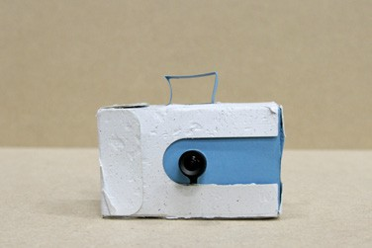 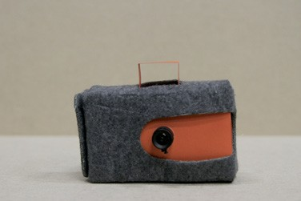 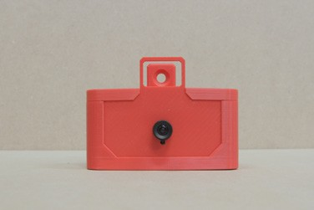 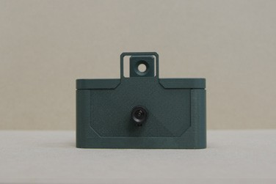 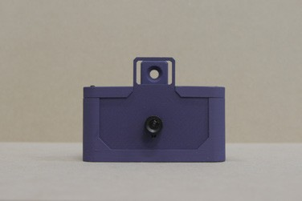

### TASKCAMS

We used TaskCams, simple digital point and shoot cameras created specifically for probe studies [3, 27], to probe into key issues, ideas and topics that we wanted our participants to respond to through photos. The TaskCams have a simple interface that allows participants to scroll through prompts displayed on an LCDscreen. We populated our TaskCams with questions (e.g. ‘things that represent minimalism’, ‘what makes your boat home?’, ‘things that bring everyone together’) as well as a set of more ambiguous terms and phrases (e.g., ‘connection’, ‘disconnection’, ‘chaos’, ‘waste’, etc.).

### TRAVELING ROCK

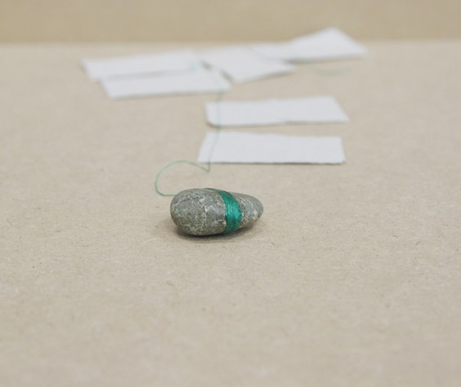The traveling rock, or

‘zwerfkei’ in Dutch, is a small rock with a string of homemade paper tags attached to it with yarn. Participants were invited to write the date, location and/or short messages on the small tags attached to

the zwerfkei. The traveling rock was meant to evoke questions one participant might have for the other, revealing where their lifestyles overlap, what they might be curious about or even where they might misunderstand each other.

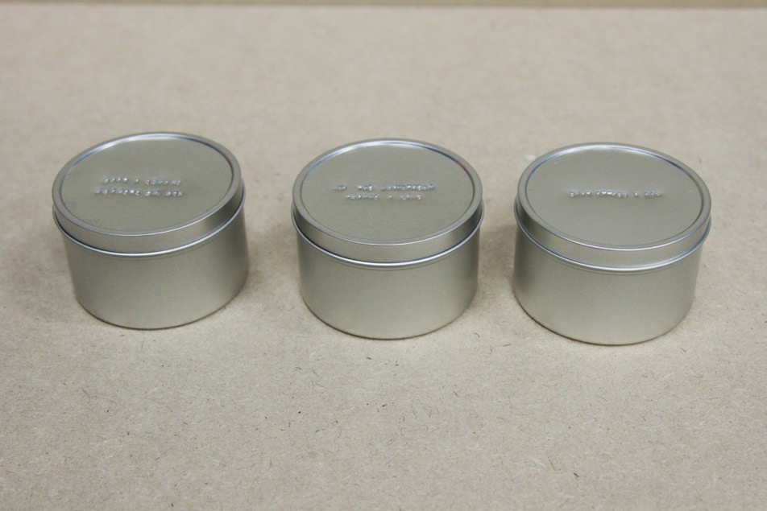

### US AND THEM

This activity consisted of three metal tins with ‘meme-like’ statements that we stamped into each of the lids using a metalworking hammer and impress typeset. The statements were: how the mainstream thinks I live; how the cashier thinks I live; and how I actually live. We presented the tins as containers for responses of how our participants felt others viewed their lifestyle, and invited them to take their time and be creative with what to put in them. We wanted to understand how our participants might have felt their lifestyle is perhaps misinterpreted or misunderstood.

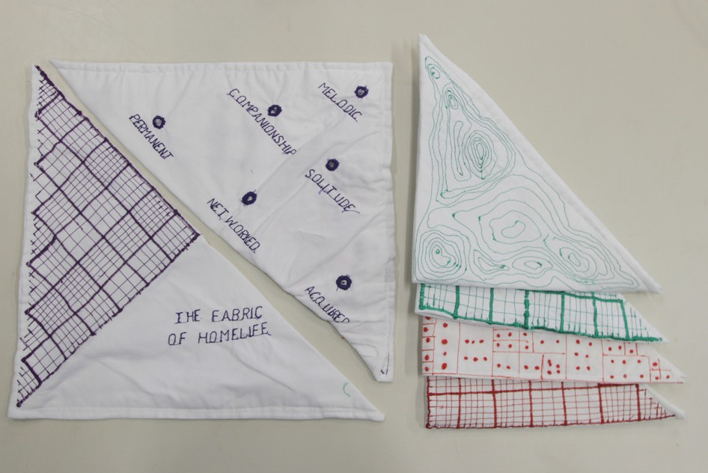

### THE FABRIC OF HOME LIFE

This task consists of two triangularly shaped pieces of fabric: on one side of each fabric, two sets of six words were embroidered that represent values of home life the participant may or may not identify with, and that may or may not contradict their experience of home; for example: melodic and chaotic, free and intentional, solitude and networked. The participants were tasked to bring the textiles together with thread we provided and to sew a pathway through the terms that they felt best represented qualities of their home life. We wanted to gain insight into the subtleties, contradictions and dynamics of the values of their home life and how these differed across our participants.

### PROMPTS WITH THE AUDIO

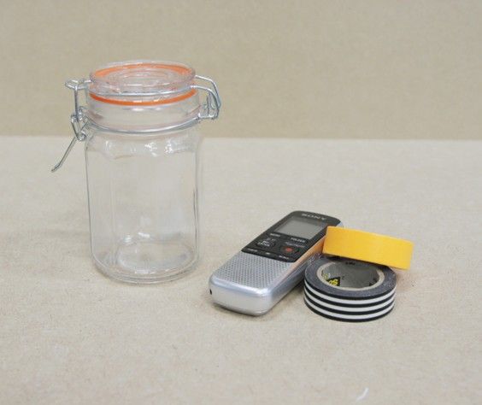**RECORDER**

We included an audio recorder in the bag and crafted several prompts that invited our participants to capture soundscapes and stories of their everyday life with us. With the Imagining In and Out activity, we

invited participants to make use of two rolls of different colored tape to outline things, spaces or functionalities that they wish they had, as well as those that they wish were no longer there. We asked participants to take a picture of the result with the TaskCam and elaborate on their choices on the recorder. Through this activity we hoped to learn more about how things contribute to or limit the specific ways of making home of our participants. The Waste Capsule is a glass jar we asked our zero waste participants

to fill with the waste they collected over the period of having the probe bags with them. The participants were asked to annotate its contents at the end, using the audio recorder. We were interested in learning how our participants considered materials of everyday life, and how their definition of and approach to waste varied.

# what is the other home?

On this page, we present conceptual floorplans that are loosely based on the returned probe materials and embody aspects and values of the living situations of our participants. We aim to highlight what makes these homes different in terms of what is included in the conceptualization of home, where the home is located and how the home is enacted. These abstractions can be seen as alternative foundations of home that guided our speculative responses and design interpretations on the following pages.



#### adaptable

In dwellings where space is limited (e.g. tiny homes, micro lofts, minimalist living) structures and furniture (e.g. murphy beds) often take on more than one function and/or can change states.

#### dynamic boundaries

Collective houses similarly deal with state changes

in space. Where some private/shared boundaries are clearly divided (e.g. bedrooms), others are negotiable and dynamically shift between private,

semi-private and shared.

#### orientated

Homes like vans and boats have a “control room” that allows dwellers to adapt their orientation, location, environment and level of connectedness. The home is simultaneously fixed

and dynamic, inviting the outside in.

#### exchange

When living is distributed over multiple fixed locations, the sense of home is extended not just across these locations, but also in the back and forth between these locations (e.g. feeling at home on the ferry, exchange of things between homes, etc.).

#### d ispersed

Nomadic living is fragmented yet highly connected. Stable locations are used for work and storage, everyday living is location-less, orientation- less and traceless. What makes home is extended beyond a physical location.

##### *Domesticating what’s traditionally*

*not considered domestic.*

A set of layered window shapes that can be pulled down to connect your actual domestic location closer to fixed domestic sites in the city (e.g., one shape for the extended park kitchen in the actual kitchen, another for a few of a particular place in a city park as a part of your extended living room).

## the extended / distributed home

Participants expressed numerous ways in which they considered settings, places, and environments outside of their dwelling quarters to be important parts of what they conceptualized as their home. For our mobile dwellers (e.g., van and boat), the core domestic setting remained fixed, while the textures and character of their extended home continually as they moved to stopped in different locations. For our nomadic pet sitter, her fixed site

of home revolved around a few core essential possessions, whereas for minimalist condo dweller ‘home’ extended into specific locations throughout the city (e.g., a frequently visited local park as a distributed kitchen/living room for cooking and gathering). While diverse, these responses highlight

Portholes in your boat or small windows in your van that can be configured to show prior scenes from your ‘extended living room’.

A portal or photo frame that continually shows the slowly changing landscape from the ferry’s perspective as it moves back and forth between Vancouver and Gambier island.

how the home can be conceptualized and designed for as a distributed relation set of fixed and dynamic points that collectively work together to evoke and enact home. Stitching together the network of relations among parts of the city, a ferry, a toiletry bag, or a scenic highway as changing facets in the fabric of everyday life opens up new possibilities to consider how technology can be designed to extend distributed, evolving spheres of domesticity.

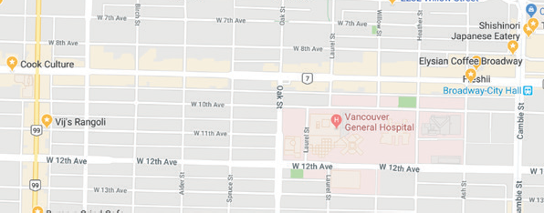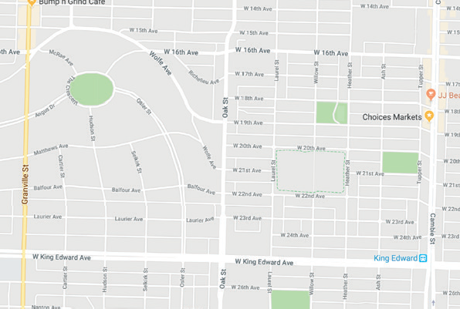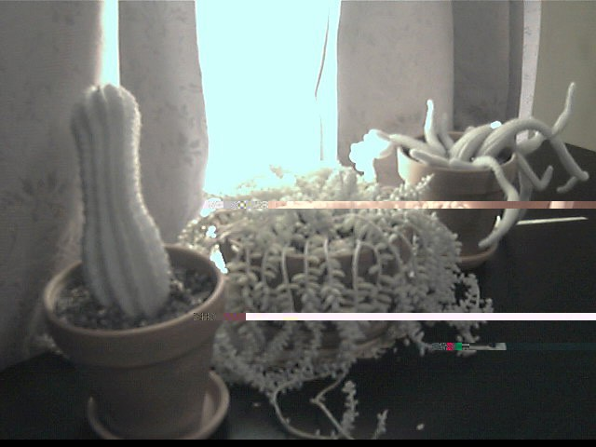

*e Maps application.*

*grounding ‘home’ in their Googl*

*point*

**Your places**

**Home**

49.257521, -123.059424

get directions

***“when you break a leaf of a succulent it will start growing roots. I kind of leave leafs all over the place too.”***

*A GPS-enabled toothbrush for nomadic home dweller provides the digital anchor*

*Home is where the toothbrush is, so you will never forget how to get back home.*

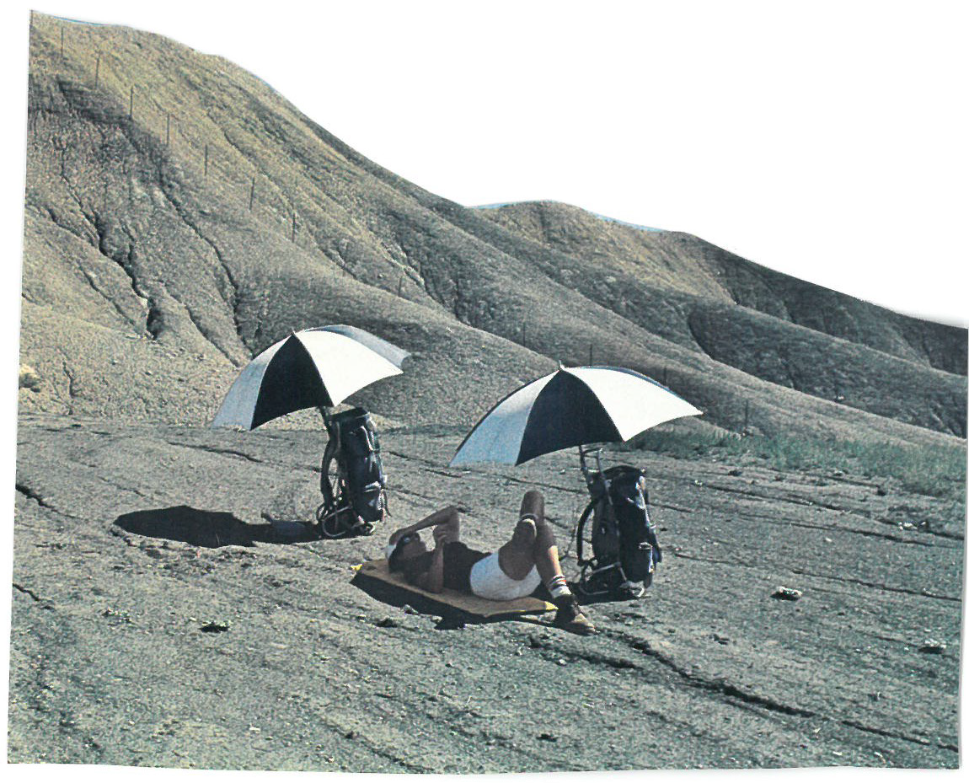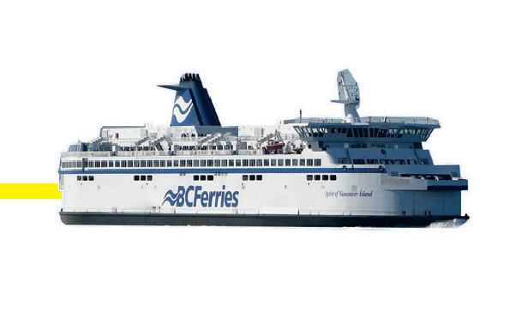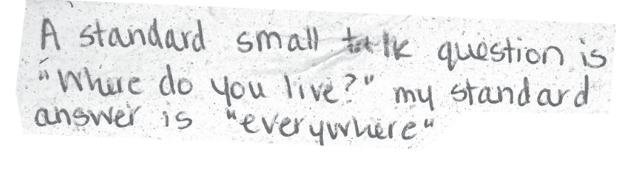

***“a huge part of home for me is how it enables me to experience life outside of the home”***

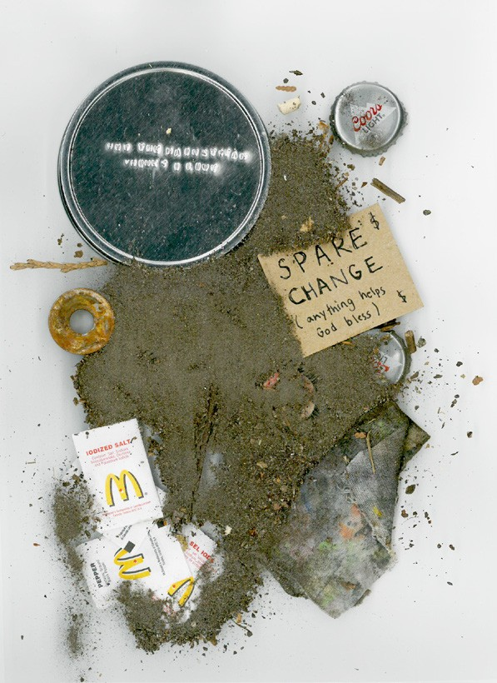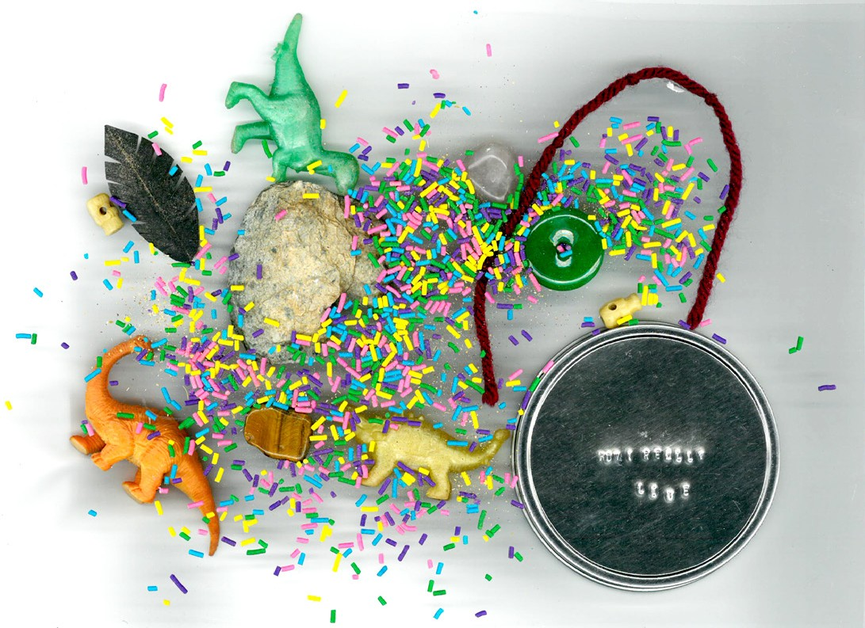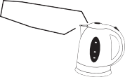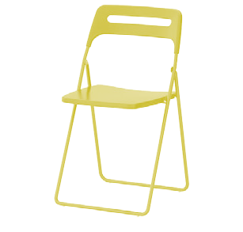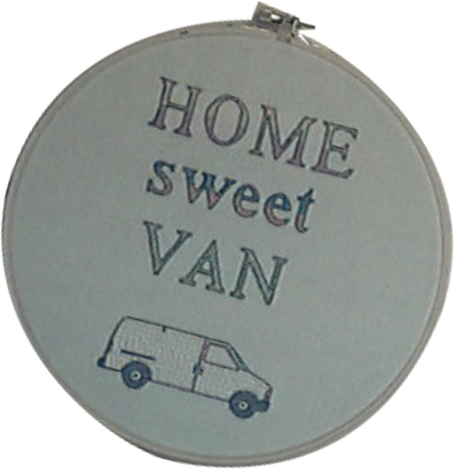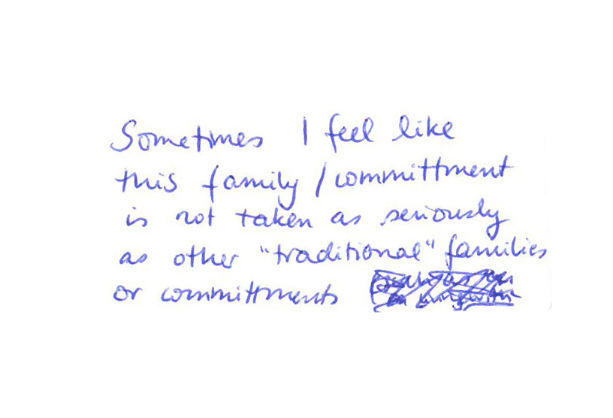

##### *Connected domestic objects and appliances* appropriated by a van dweller that capture, amplify,

*and project the mundanity of her domestic practices to normalize her van as a domestic dwelling.*

All participants expressed tensions around being viewed as non-normal, misunderstood, and not taken seriously. Consider the materials expressing a van dweller’s response to ‘how the mainstream views me’ in the us and them activity to the materials included in her ‘how I actually live’ tin (shown in the top right of this page).

Participants richly expressed their material practices of making home, often celebrating their unique domestic settings.

## the making of home

Our participants responses revealed they did not view their practices of making home to be fundamentally different from house dwellers, despite living with unique and highly diverse constraints. Indeed, the making of home life is a dynamic and ongoing process for all of us. Yet, it was also clear that they frequently felt

misunderstood by mainstream society and encountered tensions on being equally seen and treated as living ‘normal’ lives.

Recently, emerging connected domestic objects that communicate their status, such as Tweeting toasters [28], beds [29], and kettles [30], have been both lauded and highly criticized by those interested in (or concerned with) their place in in typical domestic settings. Re-appropriating such technologies in the context of our participants’ lives could offer practical utility to amplify and project the status of their mundane everyday practices comprising home life to the outside world. This approach could offer an alternative critical take on such visions of emerging technologies for ‘home life’ by opening questions about their triviality and the underlying values they are being designed to support when situated in constrained and under-recognized domestic settings. Equally, we see value in exploring how the values, practices, and desires captured in our participants’ probe responses could expand strategies

***“I put a sarong over the TV when I don’t want to get distracted”***

## the adaptable home

While our participants are highly committed to their homes and lifestyles, they also shared with us the imperfect and unromanticised elements of their living situations. They accepted these parts of their home for other elements that they would not want to miss out on. For example, while our mobile dwellers enjoy the possibility of a new view every day, this may very well include a parking lot or another undesirable view on some days. Our van dweller accepts the compromise of missing certain infrastructural luxuries as this allows her to more freely adapt her environment. Our nomadic dweller adapts herself constantly to her changing living spaces that may or may not be her taste. She further emphasizes how while this life- style is right for her at this time, she sees it as part of a longer-term plan, saving money to travel and ac- quire a tiny house. These displeasures, compromises and aspirational aspects of their homes are perhaps more unique for these dwellers, yet any dwelling will prompt wishes and

desires that lead to the ongoing, dynamic making of home. Rather than

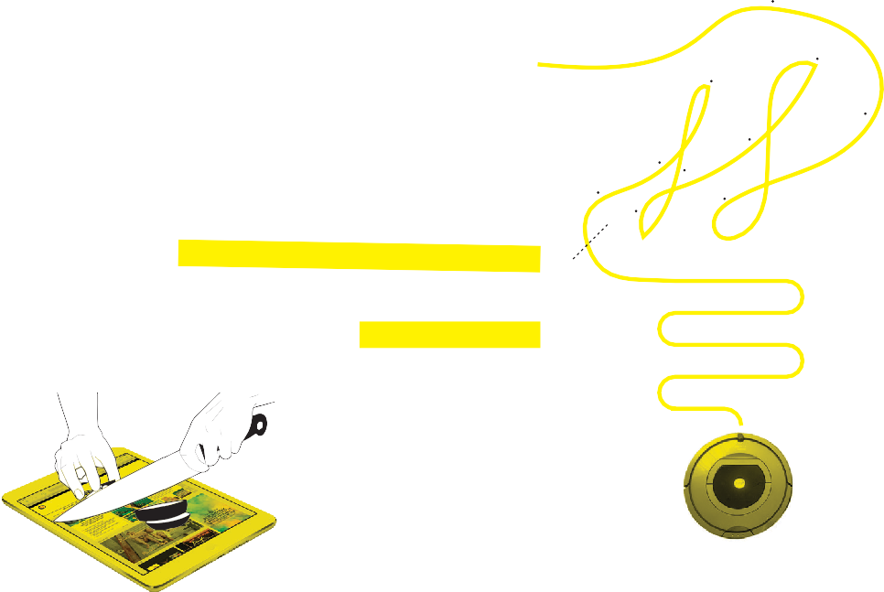responding to these elements of their home as problems to fix, we see 3

these as unique constraints that have in their actual homes already

translated into spaces that are able to change states e.g. through 3

adjustable furniture as well as in practices of making and remaking 3

spaces. In the speculative responses on this page we explore the 2

opportunity of technology to support adaptable, temporary and 2

aspirational practices in the home.

2 4 4

1 1

1

**Productivity mode Feng-shui mode Totality mode**

##### *the Sometimes-Smart vacuum*

*cleaner will do a dance when it’s*

*not connected*

When home is not fixed and you’re moving between connected and disconnected zones, IoT products and smart homes can become a little dumb. To avoid useless black boxes these Sometimes-Smart Things can change states to be useful even if you’re not online.

*These VR-goggles create a slightly augmented reality: you can decide what you accept and disguise in your living space by blocking out*

*the Sometimes Smart Lightbulb*

 *goes into party-mode when it*

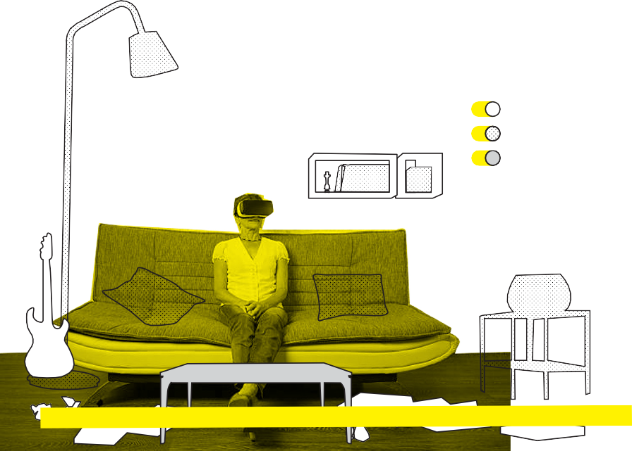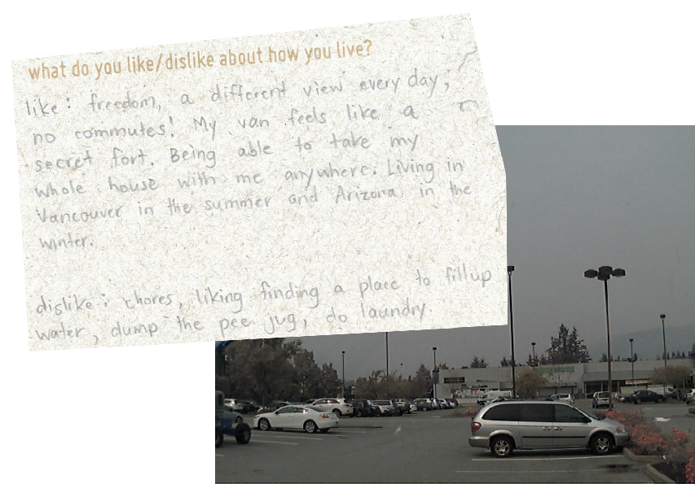

*distractions or to over time assess whether things still bring you joy.*

*elements for a while. This can be helpful to (re)create Feng-shui, to avoid*

*loses internet connection*

## tuning connectivity

Participants living in mobile, nomadic, or otherwise transitional situations as well as those living in relatively fixed domestic sites (e.g., micro loft, tiny house, collective house) expressed numerous perspectives on their respective relation to digital and network connectivity. Our mobile dwellers revealed how their movement through space to different geographic locations resulted in differing levels of connectivity as a part of daily life. In some cases, they intentionally changed their geographic location to places where they could avoid digital connectivity, only to later rejoin the digital network after moving location again. Participants that had fixed domestic sites, also expressed intentional manipulation of one’s connectivity by limiting digital connectivity in the home to ‘work time’ during specific periods of the day or only when not co-dwelling with others in the shared domestic spaces. These instances are clearly shaped by a wide range of issues – some intentional, while

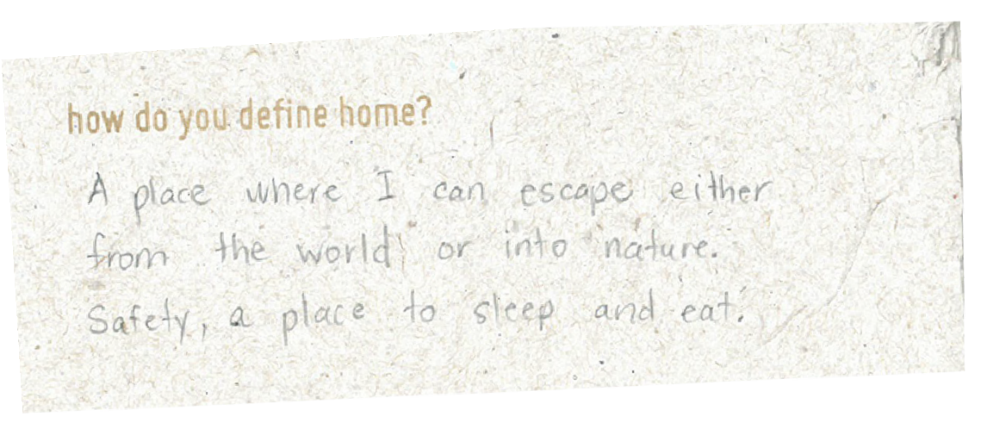others incidental or consequential of the unique constraints our participants lived with.

What we aim to draw attention to is that they suggest a continuum between neither being completely digitally connected or disconnected. We see this as inspiring a rich and intriguing design space to consider the creation of technologies that enable people with a greater capacity to manipulate and tune the granularity of digital connectivity that enshrouds our everyday home lives.

This set of devices proposes a vision of the connected home that treats digital network connectivity through a range of different forms that enable users to flexibly and directionally position short range Wi-Fi zones within their home. The ball form enables you to easily ‘give’ the one Wi-Fi position in the home to a person by merely tossing it to them; the fluffy router’s speed peaks when you pet it; the rigid yet flexible textile concept enables you to mold various aesthetic forms to configure and concentrate Wi-Fi connectivity in the home. The molded form of the textile configures the relative speed and range of the Wi-Fi. For example, in a completely flat form, e.g. as a wall hanging, the speed is slow but the range is wide; in a tightly molded form like a horn or cylinder the range of very small and targeted in one direction, but the speed is high.

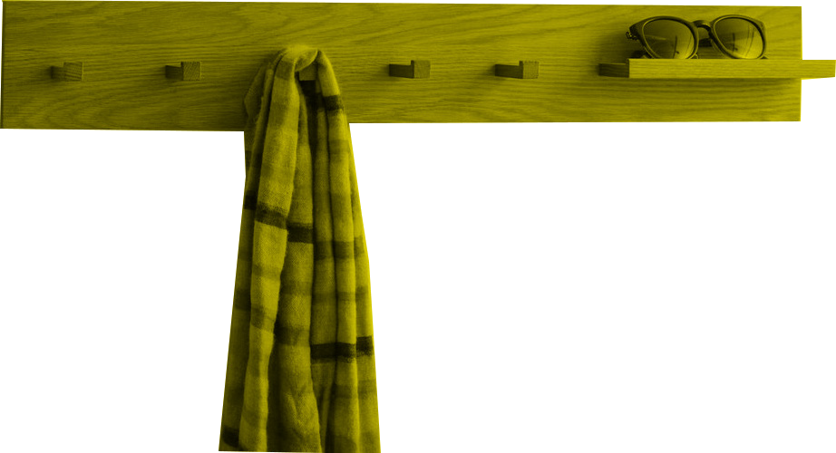

**emergencies**

**list of five friends and family**

Imagine a coatrack that configures the digital permeability of the home to the outside social world. As more family members arrive home and places their hangs up their coat or scarf, the social circle of people allowed to digitally contact members in the home shrinks, increasingly restricting the intimate domestic sphere to those most intimately known by the collective family members present. This concept represents how connectivity can be configured by leveraging mundane socio-material practices by inhabitants of the home.

Building on the coatrack concept above, we also envision a more literal approach to enabling home dwellers to tune or ‘dial in’ their desired permeability of digital connectivity to the world existing outside of their domestic sphere. Embodied in the form of a circular thermostat or radio tuner, these design proposals offer direct manipulation of domestic connectivity.

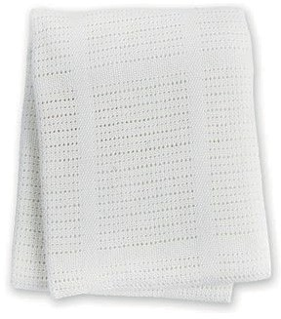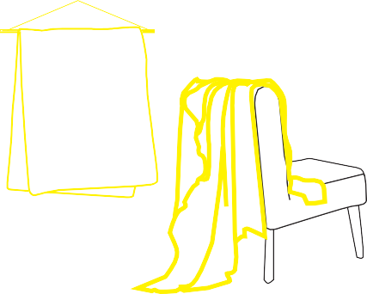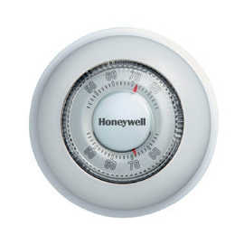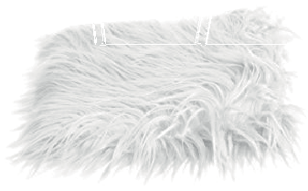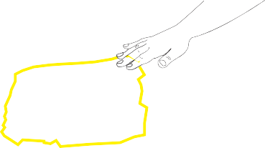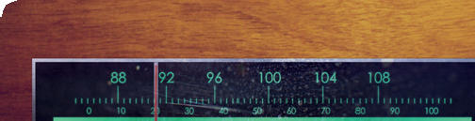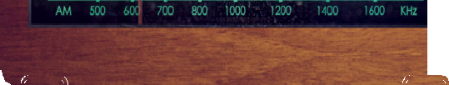

CLASSIFIEDS

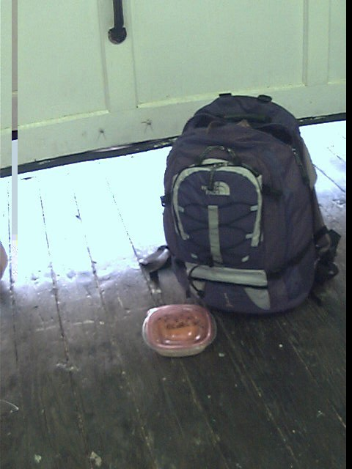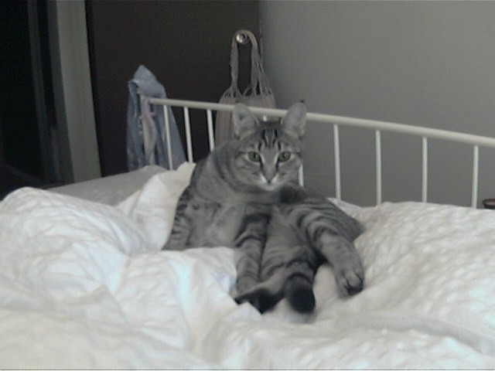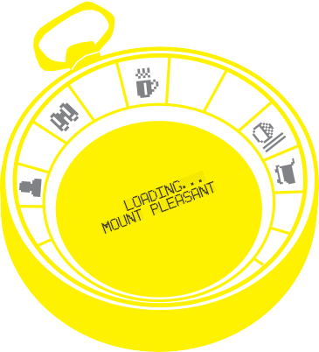

***“I see different friends depending on which neighborhood I’m in. Or do different things: in Kits and the West End I go to the beach and swim more. Mt Pleasant, I drink more coffee. North Vancouver I hibernate because no one comes out here”***

*The Social Compass keeps track of your*

*ever-changing surroundings, slowly creating*

*a long-term temporal inventory your network of*

*past dwellings and occupations*

## influence of the home on everyday life

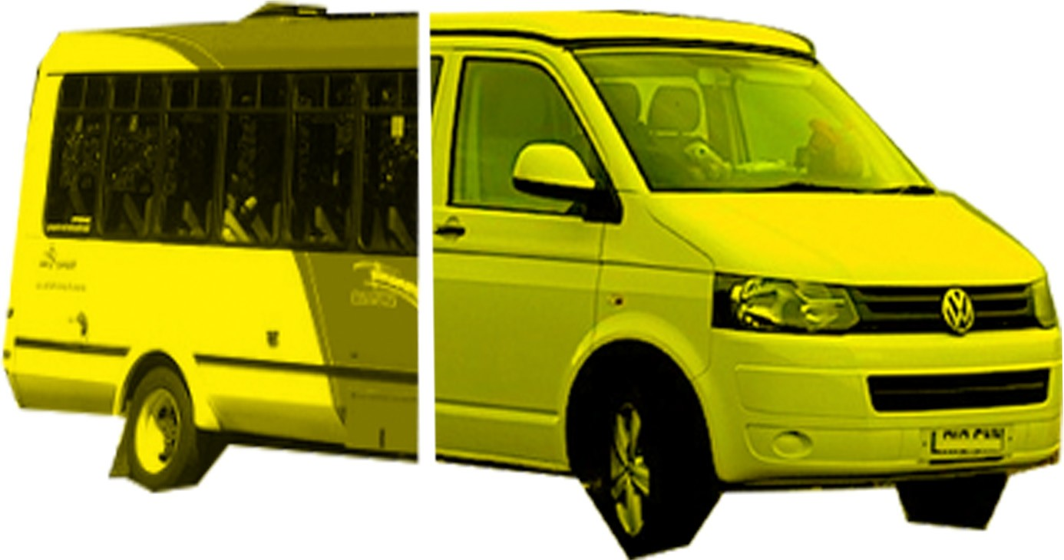

***CLOUD CLEANING***

Hi there my name is Jen, I have been a minimalist for 6 years and love living with less. I am offering my services as a cloud cleaner in exchange for a month of unlimited internet access. l will organize, clean and label your digital files for you.

*Serving all area & fully insured*

**1 Provide your cloud access**

**2 Indicate your organizational**

**preference**

**3 Pay with internet access**

**Randomness on wheels**

Need some truly randomly generated numbers? Computers alone can’t do that, but I’m about as random as it gets. Over the past four years I’ve been living and working on the go from my van. I’ve developed an algorithm that takes coordinates from my past locations and randomly assigns these to my clients. Long-term options available, please contact me for more information.

Professional Quality

**IN YOUR HOME**

Data Noise Provider and House Sitter

**Getting bored of your targeted advertisements or recommended show?**

Going on vacation soon? Maybe taking a work trip? It’s the perfect time to let your devices unlearn: bring some variety to your recommendations and mix up your advertisements. Experience with all conventional browsers, streaming services and smart home providers.

references provided, rates negotiable.

Across their probe responses, participants expressed unique and rich connections between the lived experience of their everyday home lives and their occupations outside of home. These accounts were understandably diverse. This included a zero-waste educator noting the lessons learned from living in a tiny house on a remote island where waste removal occurs only once a year to the described satisfaction from

a van dweller’s day-time occupation in the somewhat similar mobile setting as a

bus driver. Although there are notable exceptions [e.g., 14, 15], for the large part research in the DIS and HCI communities tend to see clear distinctions between home and work life. Our participants’ responses indicated the important role that embracing lessons learned from their unique domestic situations or by virtue of the constraints they lived in played important roles in their lives outside of home and in their occupations. These responses inspired us to explore and propose alternative future possibilities in which the lived experiences of people that develop and enact diverse visions of domesticity could be more richly embraced in life outside of the home.

# conclusion

Developing approaches and strategies to design interactive systems for people’s everyday lives at home continues to raise new opportunities and issues for the HCI and design communities. In this context, the overarching goal of this pictorial has been to take a modest step toward expanding how domestic life could be thought about and investigated. Design has long been regarded as an approach for framing, setting, and solving human problems, and improving the conditions of people’s everyday lives. Indeed, the HCI community has a long and important tradition of developing novel technology solutions to better support people’s domestic tasks, routines, and experiences.

Yet, design can also operate as an approach for critically provoking, imagining, questioning, and developing how we might treat such complex and diverse notions as ‘the home’ and the technologies designed in relation to it. In this way, we have sought to speculatively respond to the inspirational materials in our participants’ cultural probes kits in the service of generating openings, potentials, and possibilities for engaging with a wider range of forms of domesticity. We adopted this approach to inquire into how such insights could be materially grounded through design and what it might have to offer for design practice in the future.

We proposed *adaptable, dynamic boundaries, orientated, exchange, and dispersed* as alternative foundations for conceptualizing the home, each of which offer their own unique constraints and opportunities to consider in the design of domestic interactive systems. We then described and unpacked *the making of home, the extended / distributed home, tuning connectivity, influence of the home on everyday life, and*

*the adaptive home* as thematic collages of interpretations and speculative concepts. Taken together, these collages (i) propose alternative ways technology could be designed for the home, (ii) embody different ideas of where home is located, (iii) explore how home is constructed, re-made, curated, and pursued, and (iv) productively question material, technological, and social boundaries between the home and the outside world.

Through grounding our design research inquiry in the creation of cultural probe kits that resulted in rich materials which inspired our creation of a conceptual set of speculative proposals, our work concretely responds to growing calls in the HCI and design communities to: (a) develop alternative ways of framing and approaching the design of domestic technologies [1,10,12,14,18,21], (b) express more diverse perspectives on how ‘the home’ is conceptualized and how it can be researched [5,8,11,15,17,19,23], and, more broadly, (c) critically question underlying norms and values driving HCI research and practice [6,7,20,24]. Importantly, our aim is not to be prescriptive or conclusive. Rather, our pictorial aims to generatively inspire, frame, and expand future research inquiring into the fundamental questions of: What is home? How is it made? Where is it enacted? Why and by whom? And, how ought a technology be in this messy, diverse, and dynamic context?

### ACKNOWLEDGMENTS

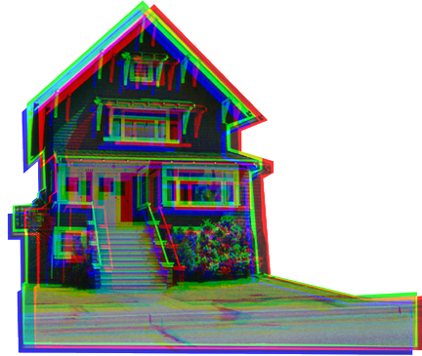This research is supported by an Insight Development Grant from the Social Sciences and Humanities Research Council of Canada. We also thank the participants that took part in our study and the Interaction Research Studio for inviting us to use and test the TaskCam platform as a part of this project. All images © Everyday Design Studio.

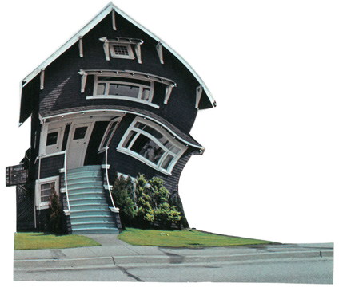 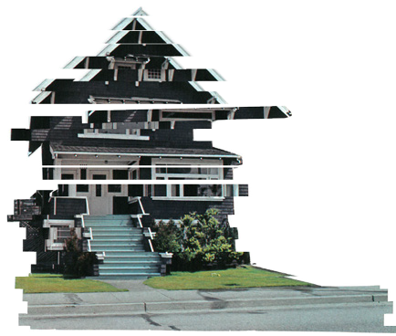

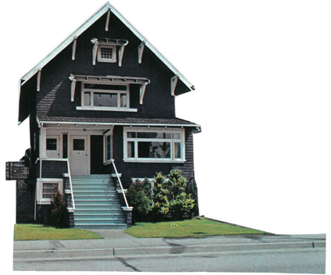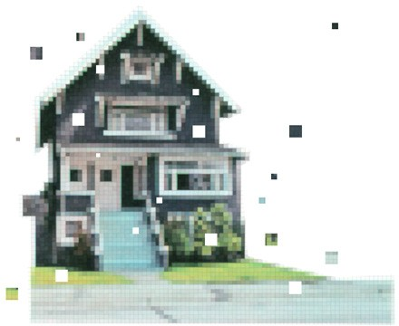

# references

1. Ryan Aipperspach, Ben Hooker, B., and Allison Woodruff. 2008. The heterogeneous home. In Proceedings of the 10th international conference on Ubiquitous computing, pp. 222-

231. ACM.

1. Luís Bettencourt, José Lobo, Dirk Helbing, Christian Kühnert, and Geoffrey B. West. 2007. Growth, innovation, scaling, and the pace of life in cities. Proceedings of the national academy of sciences 104, no. 17: 7301-7306.
2. Andy Boucher, Dean Brown, Liliana Ovalle, Andy Sheen, Mike Vanis, William Odom, Doenja Oogjes, and William Gaver. 2018. TaskCam: Designing and Testing an Open Tool for Cultural Probes Studies. In Proceedings of the SIGCHI confer- ence on Human Factors in Computing Systems (CHI ‘18). ACM, New York, NY, USA, in press.
3. Grace Campagna. 2016. Linking crowding, housing inadequa- cy, and perceived housing stress. Journal of Environmental Psychology 45: 252-266.
4. David Chatting, Gerard Wilkinson, Kevin Marshall, Audrey Desjardins, David Green, David Kirk, and Andy Boucher. 2017. Making Home: Asserting Agency in the Age of IoT. In Proceedings of the 2017 CHI Conference Extended Abstracts on Human Factors in Computing Systems, ACM, 526-533.
5. Audrey Desjardins, Ron Wakkary, and William Odom. 2015. Investigating Genres and Perspectives in HCI Research on the Home. In Proceedings of the 33rd Annual ACM Conference on Human Factors in Computing Systems (CHI ‘15). ACM, New York, NY, USA, 3073-3082.
6. Audrey Desjardins, Ron Wakkary, and William Odom. 2016. Behind the Lens: A Visual Exploration of Epistemological Commitments in HCI Research on the Home. In Proceedings of the 2016 ACM Conference on Designing Interactive Sys-

tems (DIS ‘16). ACM, New York, NY, USA, 360-376.

1. Audrey Desjardins and Ron Wakkary. 2016. Living In A Proto- type: A Reconfigured Space. In Proceedings of the 2016 CHI Conference on Human Factors in Computing Systems (CHI ‘16). ACM, New York, NY, USA, 5274-5285.
2. Bill Gaver, Tony Dunne, and Elena Pacenti. 1999. Design: cultural probes. interactions 6.1: 21-29.
3. Bill Gaver and Heather Martin. 2000. Alternatives: exploring information appliances through conceptual design proposals. In Proceedings of the SIGCHI conference on Human Factors in Computing Systems (CHI ‘00). ACM, New York, NY, USA, 209-216.
4. Tom Jenkins. 2017. Living Apart, Together: Cohousing as a Site for ICT Design. In Proceedings of the 2017 Conference on Designing Interactive Systems, pp. 1039-1051. ACM.
5. Tom Jenkins. 2015. Designing the Things of the IoT. In Pro- ceedings of the Ninth International Conference on Tangible, Embedded, and Embodied Interaction, pp. 449-452. ACM.
6. Tejinder K. Judge and Carman Neustaedter. 2014. Studying and Designing Technology for Domestic Life: Lessons from Home. Morgan Kaufmann Publishers Inc., San Francisco, CA, USA.
7. David S. Kirk, David Chatting, Paulina Yurman, and Jo-Anne Bichard. 2016. Ritual Machines I & II: Making Technology at Home. In Proceedings of the 2016 CHI Conference on Human Factors in Computing Systems (CHI ‘16). ACM, New York, NY, USA, 2474-2486.
8. Gilly Leshed, Maria Håkansson, and Joseph ‘Jofish’ Kaye. 2014. “Our life is the farm and farming is our life”: home- work coordination in organic farm families. In Proceedings of the 17th ACM conference on Computer supported coopera- tive work & social computing (CSCW ‘14). ACM, New York,

NY, USA, 487-498.

1. Justin McGuirk. 2015. Honeywell, I’m Home! The Internet of Things and the New Domestic Landscape. Retrieved 11 De- cember, 2017 from <http://www.eflux.com/journal/honeywell-> im-home-the-inte
2. William Odom, John Zimmerman, and Jodi Forlizzi. 2010. Designing for dynamic family structures: divorced families and interactive systems. In Proceedings of the 8th ACM Confer- ence on Designing Interactive Systems (DIS ‘10). ACM, New York, NY, USA, 151-160.
3. William Odom, Abigail J. Sellen, Richard Banks, David S. Kirk, Tim Regan, Mark Selby, Jodi L. Forlizzi, and John Zimmerman. 2014. Designing for slowness, anticipation and re-visitation: a long term field study of the photobox. In Proceedings of the SIGCHI Conference on Human Factors in Computing Systems (CHI ‘14). ACM, New York, NY, USA, 1961-1970.
4. Marianne Graves Petersen, Aviaja Borup Lynggaard, Pe- ter Gall Krogh, and Ida Wentzel Winther. 2010. Tactics for

homing in mobile life: a fieldwalk study of extremely mobile people. In Proceedings of the 12th international conference on Human computer interaction with mobile devices and services (MobileHCI ‘10). ACM, New York, NY, USA, 265-274.

1. James Pierce, Phoebe Sengers, Tad Hirsch, Tom Jenkins, William Gaver, and Carl DiSalvo. 2015. Expanding and Refin- ing Design and Criticality in HCI. In Proceedings of the 33rd Annual ACM Conference on Human Factors in Computing Systems (CHI ‘15). ACM, New York, NY, USA, 2083-2092.
2. James Pierce. 2016. Design Proposal for a Wireless Derouter: Speculatively Engaging Digitally Disconnected Space. In Pro- ceedings of the 2016 ACM Conference on Designing Interac-

tive Systems (DIS ‘16). ACM, New York, NY, USA, 388-402.

1. Wila Rea, Jennifer Yuen, John Engeland, and Roberto Figueroa. 2008. The dynamics of housing affordability. Per- spectives on Labour and Income, 20(1), 37.
2. Irina A. Shklovski and Scott D. Mainwaring. 2005. Exploring technology adoption and use through the lens of residential mobility. In Proceedings of the SIGCHI Conference on Human Factors in Computing Systems (CHI ‘05). ACM, New York, NY, USA, 621-630.
3. Alex S. Taylor, Susan P. Wyche, and Joseph ‘Jofish’ Kaye. 2008. Pottering by design. In Proceedings of the 5th Nordic conference on Human-computer interaction: building bridges (NordiCHI ‘08). ACM, New York, NY, USA, 363-372
4. Jill Woelfer and David Hendry. 2011. Homeless young people and living with personal digital artifacts. In Proceedings of the SIGCHI Conference on Human Factors in Computing Systems (CHI ‘11). ACM, New York, NY, USA, 1697-1706.
5. Allison Woodruff, Jay Hasbrouck, and Sally Augustin. 2008. A bright green perspective on sustainable choices. In Proceed- ings of the SIGCHI Conference on Human Factors in Comput- ing Systems (CHI ‘08). ACM, New York, NY, USA, 313-322.
6. ProbeTools: https://probetools.net
7. tweeting toaster: <http://nothans.com/social-networking-for-> my-toaster
8. tweeting bed: <http://mashable.com/2009/12/13/twitter-bed-> sex/#Ijr760K_jSqI
9. tweeting kettle: [https://www](http://www.wired.com/2010/04/twettle-the-).wir[ed.com/2010/04/twettle-the-](http://www.wired.com/2010/04/twettle-the-) story-of-a-tweeting-kettle